LAB 8
Spring 2011, BESE- 15

Submission Requirements
Complete your task during lab timings. Viva will be taken in lab session.
Master Pages:
ASP.NET master pages allow you to create a consistent layout for the pages in your application. A single master page defines the look and feel and standard behavior that you want for all of the pages (or a group of pages) in your application. You can then create individual content pages that contain the content you want to display. When users request the content pages, they merge with the master page to produce output that combines the layout of the master page with the content from the content page.

Task:

Task 1:

Creating a master page and adding content pages to it.

- In Solution Explorer, right-click the name of your Web site, and then click Add New Item.
- Under Visual Studio installed templates, click Master Page.
- In the Name box, type Master1.
- Select the Place code in separate file check box.

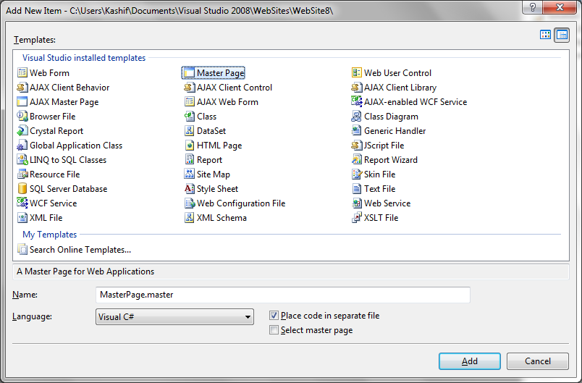

The page will have a div and a ‘ContentPlaceHolder’. The ContentPlaceHolder is where the content of individual webpages is displayed. You can add more contentPlaceHolders if you like.



- Inside the div but outside the ContentPlaceHolder add a table.
- Add an image to top row of table and a menu to left column of it. The menu shall contain some hyperlinks.

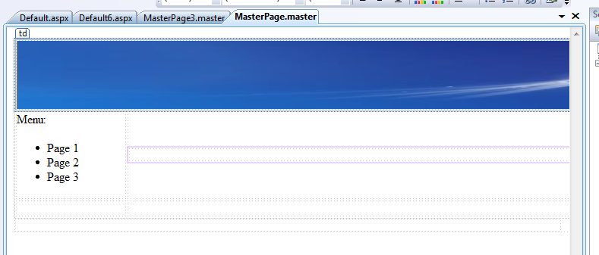

- To associate any page with this master page you can:
- Right click the name of the page in solution explorer and select ‘Add Content Page’
- Add new page from ‘Add New Items’ menu, check the checkbox for ‘Chose Master Page’ and then selecting the desired master page.
- On the content page you would be able to see the design elements added to master page but you can’t edit them.

Task 2:
Recreate the task completed in lab 4 using master pages.

